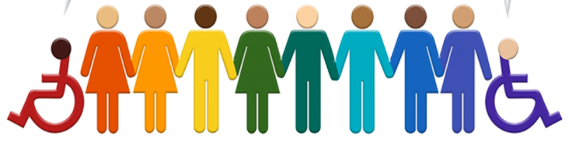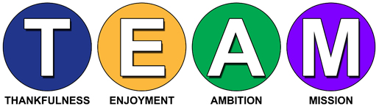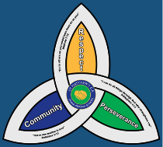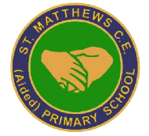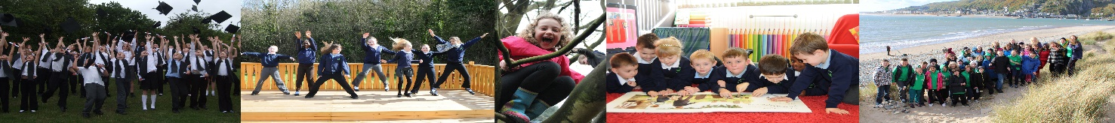I

**SEND**

**Newsletter Spring Term 2023**

**Updates from the Local Authority**

Telford and Wrekin have launch there 10 by 10, 10 things children can achieve by the age of 10. They are committed to ensuring that children with SEND can fully participate in. Please visit their website to find out more.

<https://10by10.telford.gov.uk>

In Telford & Wrekin the local partnership is committed to co-produce services with families for children and young people with special educational needs and disabilities at every stage. The SEND Working Together Charter has been developed by Parents, Carers, Children, Young People, Telford & Wrekin Council, Shropshire, Telford and Wrekin NHS and partners.

<https://www.telfordsend.org.uk/info/1/home/112/telford_and_wrekin_send_-_co-production_charter>

Telford and Wrekin aim to bring together useful information across education, health and social care within one website. You can find information, advice and guidance and a range of local service providers who support children with Special Educational Needs and Disabilities (SEND).

<https://telfordsend.org.uk/site/index.php>



**Contact details**

|  |  |  |  |
| --- | --- | --- | --- |
| St Matthew’s SEND Team | 01952 386260  01952 386274 | Family Connect | 01952 385385  [www.telford.gov.uk/info/20223/familyconnect](http://www.telford.gov.uk/info/20223/familyconnect) |
| Mrs L. Burns  SENCo | Laura.burns@taw.org.uk | Information Advice Support Service | 01952 457176  [www.telfordsendiass.org.uk](http://www.telfordsendiass.org.uk/) |
| PODs - Parents Opening Doors | 01952 271532  [www.podstelford.org/](https://www.podstelford.org/) | SEND Telford | [www.telfordsend.org.uk/site/index.php](https://www.telfordsend.org.uk/site/index.php) |

**Wellbeing and Mental Health – Parent Signposting**

|  |  |  |
| --- | --- | --- |
| **BEAM**  Image result for BEAM | All pupils | BEAM, run by The Children’s Society, is an emotional health and well-being service for children and young people across Telford and Wrekin and Shropshire. The service is available to anyone under the age of 25 and provides the opportunity to discuss, share and talk through problems in a non-judgemental environment.  [***https://www.childrenssociety.org.uk/beam/shropshire***](https://www.childrenssociety.org.uk/beam/shropshire) |
| **Bee U**  Image result for Bee U emotional health and wellbeing | All pupils | Bee U is another service that consists of 4 organisations (The Children’s Society, Kooth, Healios and Midlands Partnership NHS Foundation Trust) who deliver emotional health and wellbeing services across Shropshire and Telford & Wrekin. New drop-in and online services are available as well as Young People and Families Mental Health Service (previously CAMHS) to help you with; getting advice, getting help, getting more help, getting risk support  [**https://beeu.org.uk/**](https://beeu.org.uk/) |
| **KOOTH**  Image result for KOOTH | 11 years+ | A free, safe and anonymous place for young people to find online support and counselling. Kooth has a team of professionals who aim to provide early response to emotional wellbeing as well as emerging mental health needs via our online platform and counselling sessions. |
| **Young Minds**  Image result for Young Minds | All pupils | Young Minds is the UK’s leading charity fighting for children and young people's mental health. They work to support parents of children and young adults with mental health issues. The helpline provides support and advice to parents and carers worried about the emotional wellbeing or behaviour of a young person in their care with confidential, expert advice.  [**https://youngminds.org.uk/**](https://youngminds.org.uk/) |

