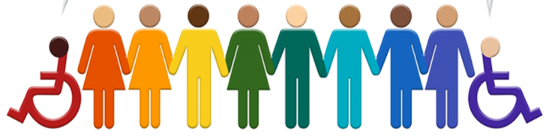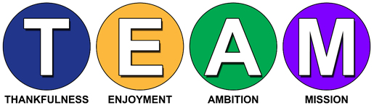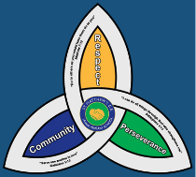**I

**Newsletter Autumn Term 2023-2024**

**Meet the Team**

|  |  |
| --- | --- |
|   **SENCo**  My name is **Mrs Burns** and I joined the team at St Matthew’s as the SENCo last year. I oversee the provision for all SEND pupils from Nursery through to Year 6, so I will be your point of call if you feel that you have any concerns relating to your child’s development, learning or progress.  The SEND team at St Matthew’s are regularly looking for ways to improve the provision for SEND pupils and their parents. This SEND newsletter is a way for the team to liaise with parents sharing with you new initiatives, changes to legislation and our achievements and successes. The newsletter will be produced termly and will keep you up to date with everything that is happening in relation to SEND at St Matthew’s. |   **Pastoral Manager**  My name is **Mrs Cadman** and I work with all children who need help to overcome difficulties that may prevent their learning. The variety of issues covered is vast, ranging from punctuality, challenging behaviour, low self-esteem, lack of confidence and raising academic achievement.  I support children to develop positive mental health and wellbeing; allowing them to enjoy learning.  I am also the school ELSA (Emotional literacy assistant support) this role enables me to support children to identify how they may be feeling and why; supporting them to manage their feelings in a positive way.  If you have any concerns regarding your child’s welfare, I am always happy to talk through them with you. |
| **SEND Governor**  My name is **Bev Porter**, and I am the governor with responsibilities for SEND (Special Educational Needs and Disabilities). I have a wealth of experience and knowledge in the areas of Speech, Language and Communication Needs, Autism Conditions, Dyslexia and DCD/ Dyspraxia. Having previously worked at a strategic level for the Local Authority.  In my role as governor, I aim to support Mrs Burns, the new SENCo, to provide the best possible outcomes for pupils with SEND at St Matthew’, by ensuring that matters relating to SEND continue to stay on the governing body agenda.  Parental engagement has always played a key role in a child’s education so please become involved by letting us know your comments, views, and ideas on ways forward. | |

**SEND Local Offer**

The Telford and Wrekin local offer aim to bring together useful information across education, health, and

social care within one website. You can find information, advice and guidance across a range of local service

providers who support children and young people with Special Education Needs and Disabilities (SEND).

Telford and Wrekin Local offer - [SEND - Local offer (telfordsend.org.uk)](https://www.telfordsend.org.uk/site/index.php) www.telfordsend.org.uk/site/index.php





**Contact details**

|  |  |  |  |
| --- | --- | --- | --- |
| St Matthew’s SEND Team | 01952 386260  01952 386274 | Family Connect | 01952 385385  [www.telford.gov.uk/info/20223/familyconnect](http://www.telford.gov.uk/info/20223/familyconnect) |
| Mrs L. Burns  SENCo | Laura.burns@taw.org.uk | Information Advice Support Service | 01952 457176  [www.telfordsendiass.org.uk](http://www.telfordsendiass.org.uk/) |
| PODs - Parents Opening Doors | 01952 271532  [www.podstelford.org/](https://www.podstelford.org/) | SEND Telford | [www.telfordsend.org.uk/site/index.php](https://www.telfordsend.org.uk/site/index.php) |

**Wellbeing and Mental Health – Parent Signposting**

|  |  |  |
| --- | --- | --- |
| **BEAM**  Image result for BEAM | All pupils | BEAM, run by The Children’s Society, is an emotional health and well-being service for children and young people across Telford and Wrekin and Shropshire. The service is available to anyone under the age of 25 and provides the opportunity to discuss, share and talk through problems in a non-judgemental environment.  [***https://www.childrenssociety.org.uk/beam/shropshire***](https://www.childrenssociety.org.uk/beam/shropshire) |
| **Bee U**  Image result for Bee U emotional health and wellbeing | All pupils | Bee U is another service that consists of 4 organisations (The Children’s Society, Kooth, Healios and Midlands Partnership NHS Foundation Trust) who deliver emotional health and wellbeing services across Shropshire and Telford & Wrekin. New drop-in and online services are available as well as Young People and Families Mental Health Service (previously CAMHS) to help you with; getting advice, getting help, getting more help, getting risk support  [**https://beeu.org.uk/**](https://beeu.org.uk/) |
| **KOOTH**  Image result for KOOTH | 11 years+ | A free, safe and anonymous place for young people to find online support and counselling. Kooth has a team of professionals who aim to provide early response to emotional wellbeing as well as emerging mental health needs via our online platform and counselling sessions. |
| **Young Minds**  Image result for Young Minds | All pupils | Young Minds is the UK’s leading charity fighting for children and young people's mental health. They work to support parents of children and young adults with mental health issues. The helpline provides support and advice to parents and carers worried about the emotional wellbeing or behaviour of a young person in their care with confidential, expert advice.  [**https://youngminds.org.uk/**](https://youngminds.org.uk/) |

