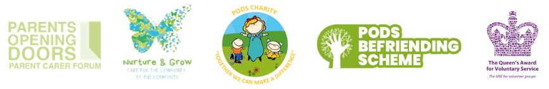
Hello Laura
PODS After School Clubs & Lots More...
PODS Lego Club
PODS Lego Club is on every Wednesday from 4.30pm-5.30pm (Term Time Only) at PODS Hub, 1 Hawksworth Road, Central Park, Telford, TF2 9TU
PODS Lego Club is running sessions for children from 5-14 years old during Term Time. The children will be building as well as be able to improve their to social and communication skills.
Session costs are non-refundable, parent/carer/PA must remain on site for the duration of the session. Please ensure every child/young person attending has a ticket.
To book, please click here: PODS Lego Club

PODS Stop Motion Video Club
PODS Stop Motion Club is held fortnightly on a Monday from 4.30pm-5.30pm (Term Time Only) at PODS Hub, 1 Hawksworth Road, Central Park, Telford, TF2 9TU
The children/young people will be provided with Lego and Ipads to help make the stop motion videos.
Costs: £3 per child/young person (Non refundable)
Please contact Uma at uma@podstelford.org for any details.
To book, please click here: PODS Stop Motion Video Club
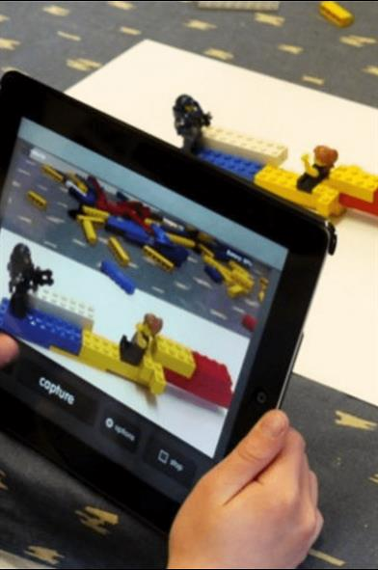
PODS Minecraft Club
PODS Minecraft Club is on every Tuesday from 4pm-5pm (Term Time Only) at PODS Hub, 1 Hawksworth Road, Central Park, Telford, TF2 9TU
A chance to come together and enjoy a session of Minecraft. Please note Minecraft will be accessed via PODS iPads which are linked to one another to allow multiplayer options. Children will not be able to access their own Minecraft accounts for safety reasons.
Sessions open to children and young people of all ages who are members of PODS including their siblings.
Drinks and biscuits provided. Session costs are non-refundable, parent/carer/PA must remain on site for the duration of the session. Please ensure every Child/young person attending has a ticket, those attending without a ticket will be turned away. Adult tickets are NOT required.
To book, please click here: PODS Minecraft Club

PODS January Activities
Join PODS in January for a variety of activity sessions! Parents and carers must attend and tickets are required for all children and young people. Open to children and young people, including siblings.
To book, please click the links below:
Craft Session
Trains & Construction
Ice Skating - SOLD OUT
Games & Tech
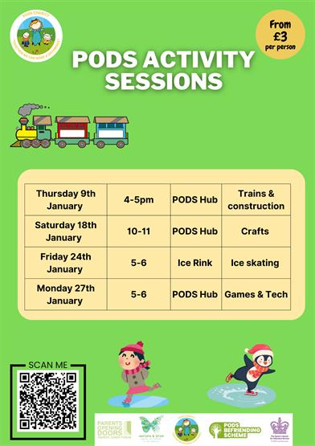
PODS Inclusive 80s Party Night Fundraiser
Thursday 23rd January 2025 from 6pm-10pm at Casey's, Cordingley Hall, Wellington Rd, Donnington, Telford TF2 8JS
We are pleased to announce our first fundraising event of 2025, 80's Disco evening. but we need your help to make it successful!
To reach our minimum target, we need to sell at least 80 tickets.
Maybe purchase them as a Christmas gift for a friend or family member!
For every ticket sold, PODS will receive £2.50.
This could be a fun way to support our charity, lift our spirits after the holidays, and enjoy some time together.
Thank you for your support!
To book, please click here: PODS Inclusive 80s Party Night Fundraiser

Nurture & Grow
Care in the Community by the Community
Nurture and Grow provides specialist PA support for children and young people aged 0-25 with disabilities and additional needs.
We are now accepting applications for support from individuals who are self funding or using direct payments.
Please follow the QR code in the poster or click below to apply:
Nurture & Grow Personal Support Application
Fully trained support workers providing 1:1 and 2:1 care.
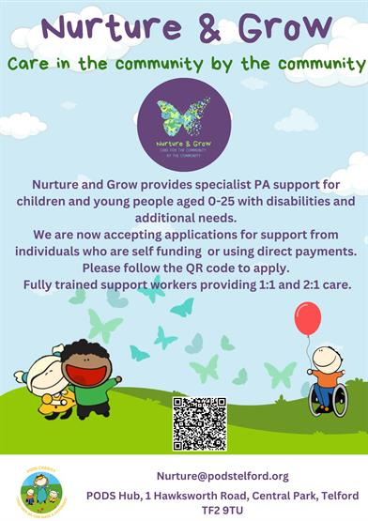
Blossom & Bloom Stay and Play Session
Blossom & Bloom is a stay and play session for infants and pre-schoolers aged 0-5. There will be fun activities every week, come for a coffee, meet other parents in our welcome and inclusive environment.
This will be open to all children prior and post diagnosis, this group every Tuesday term-time only it will run 10-11.30 at PODS hub for any extra information contact Louise@podstelford.org
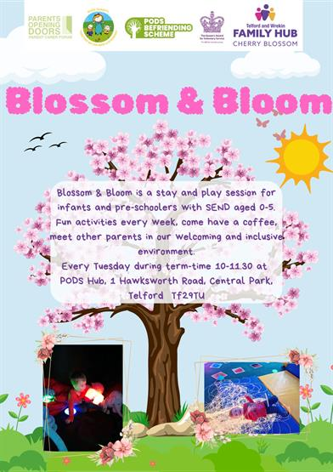
Matt Drew's Hike up Ben Nevis Fundraiser for PODS
Sharing from Matt Drew's Fundraising Page on Facebook...
"On Sunday 13th April, I will be hiking up Ben Nevis in Scotland to raise money for PODS which have been and continue to be a wonderful charity to me and my family, and other families around the Telford area.
Please donate whatever you can for this great charity."
To donate, please click here: Matt Drew's Hike up Ben Nevis Fundraiser for PODS
Upcoming Law Commission Events (In-Person and Online)
Sharing from The Law Commission...
"The Law Commission is reviewing the legal framework governing social care for disabled children in England to ensure that the law is fair, modern and accessible, allowing children with disabilities to access the support they need.
We have published a consultation paper asking people to tell us about their experiences of the current system and setting out our provisional proposals on how it could be improved. We invite views on these proposals. The consultation is open until 20 January 2025.
The consultation paper is available here. A summary can be accessed here."
You can book on to the events here: Upcoming Law Commission Events (In-Person and Online)
Change NHS Local Online Workshops
Sharing from NHS Shropshire, Telford and Wrekin...
"To ensure the views of our local population feed into the national 10-Year Health Plan as part of the Change NHS period of engagement, we are hosting two online local public workshops.
If you would like to get involved and attend a workshop please register using the link:
Friday 24th January 2025 from 10am to 12noon: https://re-url.uk/W1AN
Thursday 30th January 2025 from 6pm to 8pm: https://re-url.uk/W1ZU
Each workshop will focus on the three big changes to be included in the plan:
- Use better technology in health and care
- Move some care from hospitals to communities
- Do more to stop people getting ill.
If you are unable to attend a workshop you can complete the Change NHS online survey: Project: Start here | Change NHS
As well as the online workshops, we are attending different community groups to capture the views of those experiencing the greatest health inequalities. If you would like to propose a group for our engagement team to speak to, please email stw.getinvolved@nhs.net"
Think Which Campaign - Easy Read Version
Please click on the following link to view the easy-read version of the ‘Think Which’ service campaign: Think Which Campaign - Easy Read Version
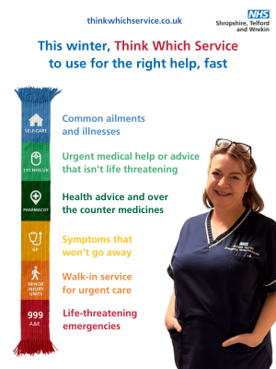
Calling all Future Artists! Developer Launches Competition to Design Art for Accessible Playground
A national housing developer has launched a competition for young people in Telford, letting them have the chance to design the art that will be showcased on its accessible play area at Hadley Gate, its development in the town.
As part of the planning permission for the development, Persimmon Homes will be creating a new accessible play area and is inviting young people in Telford to have the opportunity to have their artwork permanently displayed there. Working with PODS Parent and Carer forum, the developer has chosen nature as the theme.
Young people aged between 3 and 15 are invited to share their designs, with the team offering the winner the prize of a £100 gift card to Smyths or Amazon.
The winning design will be used as inspiration for the artist who will re-create the art, for it to be displayed permanently.
Entrants should email their design to taylor.robinson@persimmonhomes.com with the subject line ‘Hadley Arts’, leaving their name, age, school and contact information.
The deadline for entries is Friday 31st January 2025, with a winner chosen on Monday 17th February 2025.
Young Minds Mental Health Support - Parent Helpline Info Session
Tuesday 14th January 2025 from 6pm-7pm
We are very pleased to host the following information session for families: YoungMinds is the UK’s leading charity fighting for young people’s mental health.
YoungMinds offers a free, national Helpline service for any parent or carer concerned about a young person's wellbeing or mental health, aged 0-25. They can provide translation services in over 200 languages and have comprehensive resources on the Parent and Carer section of their website: You can visit the website here: wwwyoungminds.org.uk/parents-helpline
Jill Walsh is a Parent Engagement Officer at YoungMinds and will be hosting an information session where you can find out more about the Parents Helpline and the support it offers.
A link will be sent to you join us online, a few days before the event.
To book, please click here: Young Minds Mental Health Support - Parent Helpline Info Session

Help to Gather Insights to Improve Support for Young People Becoming Adults
Sharing from Think Local Act Personal...
"Think Local Act Personal are inviting you, as a parent/carer, to take part in a co-produced survey to improve support for young people preparing for adulthood.
This short survey focuses on practical solutions, better information, and ideas that could improve this experience for young people and their families and friends.
If you can spare a few minutes, please share your insights."
Action for Happiness Calendar - Happier January 2025
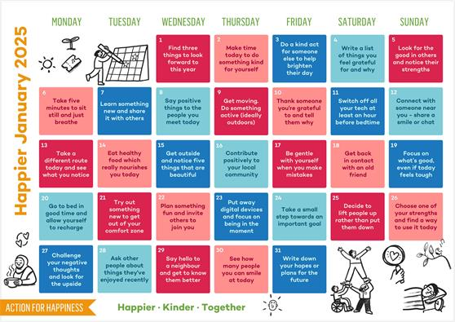
Please note the above material is subject to copyright, please contact PODS before sharing any of the information in this PODS Ebulletin.
Thank you for reading our latest Ebulletin, please stay safe & well.
Kerrie Seagrave, Member Support Co-ordinator
on behalf of PODS Parent Carer Forum.

We hope you enjoyed reading our latest e-bulletin - we hope you continue to find it useful. If you have any suggestions to make it better feel free to let me know.

