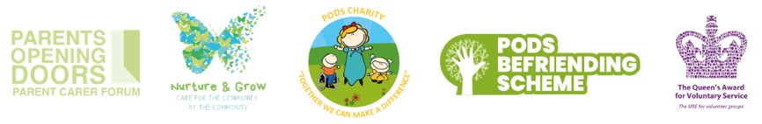
Hello Laura
PODS January Activities & Lots More...
PLEASE NOTE: This will be the last Ebulletin until the New Year.
PODS January Activities
Join PODS in January for a variety of activity sessions! Parents and carers must attend and tickets are required for all children and young people. Open to children and young people, including siblings.
To book, please click the links below:
Craft Session
Trains & Construction
Ice Skating
Games & Tech
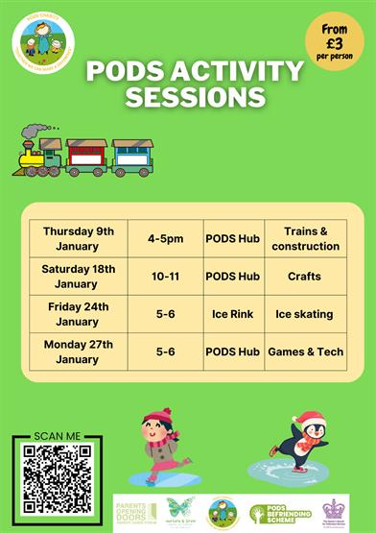
Merry Christmas from All at PODS
Wishing all our families, members and community partners a wonderful Christmas, in what ever form this may take for you.
Please note during the festive period there will be restricted availability from PODS staff between Monday 23rd December 2024 through to Friday 3rd January 2025, our hub will also be closed during this time except for pre booked activities.
Posts will not be approved between 24th December and 26th December whilst our PODS Elves take a well earned rest. If you need to speak with the team urgently please send a message to the PODS inbox and these will be picked up as soon as feasibly possible. Alternatively below are a list of organisations that are able to support you throughout the festive period.
Family Connect: (Monday – Friday 9am – 5pm excluding bank holidays) 01952 385385
Emergency Duty Team: For anyone who has immediate safeguarding concerns outside of office hours or on a bank holiday, including Christmas Day is 01952 676500.
Childline: 0800 1111 (for children) 0808 802 5544 (for parents)
National Domestic Abuse Helpline: (24/7) 0808 2000 247
Urgent NHS Mental Health Helpline: (24/7) 0808 196 4501
Samaritans: (24/7) 116 123
Mind: 0300 123 3393
Citizen’s Advice: 0800 144 8848
Corum: 020 7520 0300
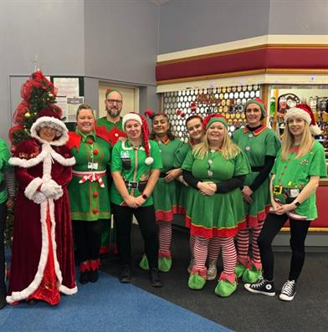
PODS Inclusive 80s Party Night Fundraiser
Thursday 23rd January 2025 from 6pm-10pm at Casey's, Cordingley Hall, Wellington Rd, Donnington, Telford TF2 8JS
We are pleased to announce our first fundraising event of 2025, 80's Disco evening. but we need your help to make it successful!
To reach our minimum target, we need to sell at least 80 tickets.
Maybe purchase them as a Christmas gift for a friend or family member!
For every ticket sold, PODS will receive £2.50.
This could be a fun way to support our charity, lift our spirits after the holidays, and enjoy some time together.
Thank you for your support!
To book, please click here: PODS Inclusive 80s Party Night Fundraiser

PODS Minecraft Club
PODS Minecraft Club is on every Tuesday from 4pm-5pm (Term Time Only) at PODS Hub, 1 Hawksworth Road, Central Park, Telford, TF2 9TU
A chance to come together and enjoy a session of Minecraft. Please note Minecraft will be accessed via PODS iPads which are linked to one another to allow multiplayer options. Children will not be able to access their own Minecraft accounts for safety reasons.
Sessions open to children and young people of all ages who are members of PODS including their siblings.
Drinks and biscuits provided. Session costs are non-refundable, parent/carer/PA must remain on site for the duration of the session. Please ensure every Child/young person attending has a ticket, those attending without a ticket will be turned away. Adult tickets are NOT required.
To book, please click here: PODS Minecraft Club

Nurture & Grow
Care in the Community by the Community
Nurture and Grow provides specialist PA support for children and young people aged 0-25 with disabilities and additional needs.
We are now accepting applications for support from individuals who are self funding or using direct payments.
Please follow the QR code in the poster or click below to apply:
Nurture & Grow Personal Support Application
Fully trained support workers providing 1:1 and 2:1 care.
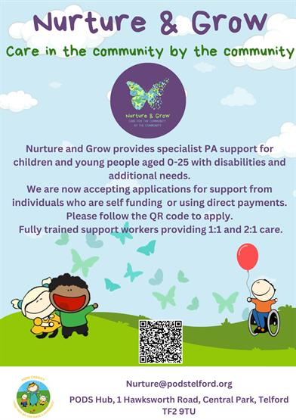
Blossom & Bloom Stay and Play Session
Blossom & Bloom is a stay and play session for infants and pre-schoolers aged 0-5. There will be fun activities every week, come for a coffee, meet other parents in our welcome and inclusive environment.
This will be open to all children prior and post diagnosis, this group every Tuesday term-time only it will run 10-11.30 at PODS hub for any extra information contact Louise@podstelford.org
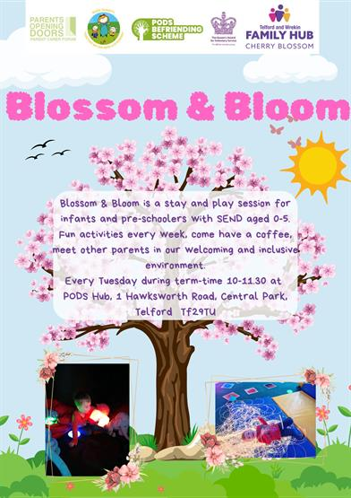
Calling all Future Artists! Developer Launches Competition to Design Art for Accessible Playground
A national housing developer has launched a competition for young people in Telford, letting them have the chance to design the art that will be showcased on its accessible play area at Hadley Gate, its development in the town.
As part of the planning permission for the development, Persimmon Homes will be creating a new accessible play area and is inviting young people in Telford to have the opportunity to have their artwork permanently displayed there. Working with PODS Parent and Carer forum, the developer has chosen nature as the theme.
Young people aged between 3 and 15 are invited to share their designs, with the team offering the winner the prize of a £100 gift card to Smyths or Amazon.
The winning design will be used as inspiration for the artist who will re-create the art, for it to be displayed permanently.
Entrants should email their design to taylor.robinson@persimmonhomes.com with the subject line ‘Hadley Arts’, leaving their name, age, school and contact information.
The deadline for entries is Friday 31st January 2025, with a winner chosen on Monday 17th February 2025.
Upcoming Law Commission Events (In-Person and Online)
Sharing from The Law Commission...
"The Law Commission is reviewing the legal framework governing social care for disabled children in England to ensure that the law is fair, modern and accessible, allowing children with disabilities to access the support they need.
We have published a consultation paper asking people to tell us about their experiences of the current system and setting out our provisional proposals on how it could be improved. We invite views on these proposals. The consultation is open until 20 January 2025.
The consultation paper is available here. A summary can be accessed here."
You can book on to the events here: Upcoming Law Commission Events (In-Person and Online)
Update on the Children and Young People Mental Health Service - Core and Neurodevelopment Services
Please see below for an update on the Shropshire, Telford and Wrekin Children and Young People’s Mental Health Services.
To read the update in full, please click here: Update on the Children and Young People Mental Health Service - Core and Neurodevelopment Services
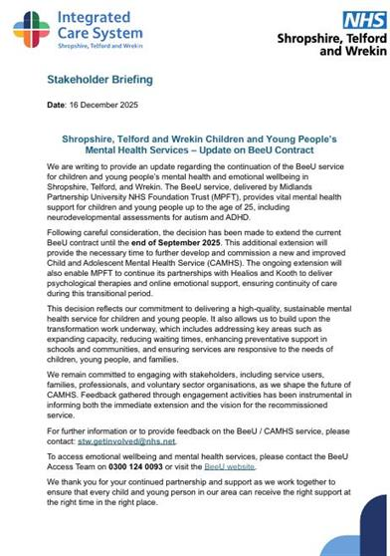
Young Minds Mental Health Support - Parent Helpline Info Session
Tuesday 14th January 2025 from 6pm-7pm
We are very pleased to host the following information session for families: YoungMinds is the UK’s leading charity fighting for young people’s mental health.
YoungMinds offers a free, national Helpline service for any parent or carer concerned about a young person's wellbeing or mental health, aged 0-25. They can provide translation services in over 200 languages and have comprehensive resources on the Parent and Carer section of their website: You can visit the website here: wwwyoungminds.org.uk/parents-helpline
Jill Walsh is a Parent Engagement Officer at YoungMinds and will be hosting an information session where you can find out more about the Parents Helpline and the support it offers.
A link will be sent to you join us online, a few days before the event.
To book, please click here: Young Minds Mental Health Support - Parent Helpline Info Session

Yvonne Newbold - Some Christmas Tips that might Help with Behaviour
Sharing from Yvonne Newbold...
"Christmas, as we all know, can be very difficult for SEND children, and particularly for those who become overwhelmed with anxiety which can cause a significant deterioration in behaviour.
Christmas time is supposed to be magical for children, but the very things that make it so special for many are exactly the things which can cause anxiety levels to sky-rocket for children in our Newbold Hope community, with a sometimes devastating accompanying impact on behaviour.
I've shared 3 tips on the video below, to help with the behavioural challenges which Christmas can bring, and I'm hoping to share some more tips in the next few days as well."
To view the video, please click here: Yvonne Newbold - Some Christmas Tips that might Help with Behaviour

Action for Happiness Calendar - December Kindness 2024
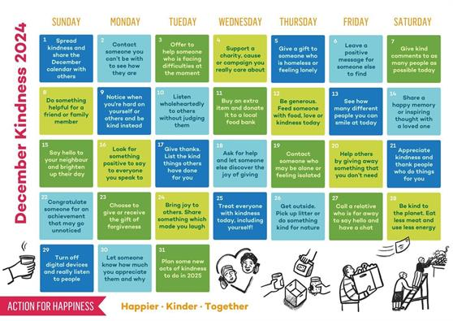
Please note the above material is subject to copyright, please contact PODS before sharing any of the information in this PODS Ebulletin.
Thank you for reading our latest Ebulletin, please stay safe & well.
Kerrie Seagrave, Member Support Co-ordinator
on behalf of PODS Parent Carer Forum.

We hope you enjoyed reading our latest e-bulletin - we hope you continue to find it useful. If you have any suggestions to make it better feel free to let me know.

