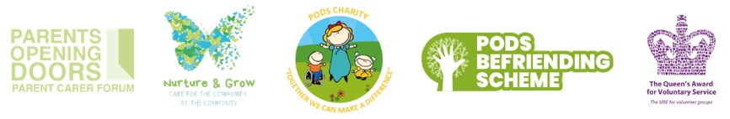
Hello Laura
PODS February & Half Term Activities & Lots More...
PODS February Activities
Join PODS this February for a variety of activity sessions! Parents and carers must attend and tickets are required for all children and young people.
Open to children and young people, including siblings.
To book, please click the links below:
Thursday 6th February - Trains & Construction
Saturday 8th February - Blist Hill Museum
Thursday 13th February - Valentines Day Crafts Session
Thursday 27th February - Drawing Session
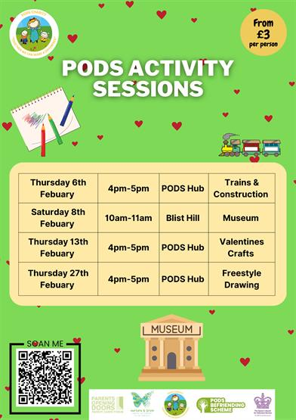
PODS February Half Term Activities
Join PODS in February Half Term for a variety of activity sessions! Parents and carers must attend and tickets are required for all children and young people.
Open to children and young people, including siblings.
To book, please click the links below:
Saturday 15th February - Cooking Session
Monday 17th February - Pancake Session
Wednesday 19th February - Blist Hill Museum
Friday 21st February - Gardening Session
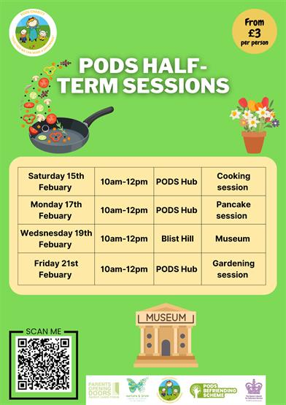
PODS Pre-School Sensory Sessions
Join our warm welcoming staff for our pre-school sensory sessions on a Friday morning 10.30am-11.30am during term-time.
The sessions are held at PODS Hub, this session is for children from 0-5. Please only take photos of your own children.
No refunds available.
These will begin on the 31st January. To book, please click here: PODS Pre-School Sensory Sessions
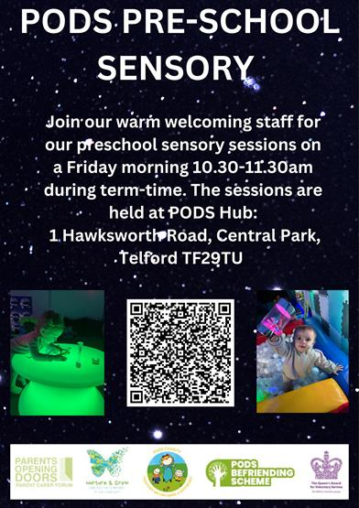
PODS Sensory Sessions
PODS Sensory Sessions are held at PODS Hub, 1 Hawksworth Road, Central Park, Telford, TF2 9TU.
Siblings are also welcome. Parent/carer supervision required at all times.
We have availability on the 0-6 years and 7-11 years sessions. Please click on the following links to book:
Wednesday 22nd January 2025 from 3.45pm-4.45pm - PODS Sensory Sessions Age 7-11
Monday 27th January 2025 from 3.45pm-4.45pm - PODS Sensory Sessions for Ages 0-6

PODS Inclusive 80s Party Night Fundraiser - **Event Cancellation Announcement**
We regret to inform you that this event has been cancelled due to insufficient interest.
For the few who have purchased tickets, Casey’s venue will be processing refunds.
We sincerely apologise for any disappointment this may cause and appreciate your understanding. Thank you.

PODS Minecraft Club
PODS Minecraft Club is on every Tuesday from 4pm-5pm (Term Time Only) at PODS Hub, 1 Hawksworth Road, Central Park, Telford, TF2 9TU
A chance to come together and enjoy a session of Minecraft. Please note Minecraft will be accessed via PODS iPads which are linked to one another to allow multiplayer options. Children will not be able to access their own Minecraft accounts for safety reasons.
Sessions open to children and young people of all ages who are members of PODS including their siblings.
Drinks and biscuits provided. Session costs are non-refundable, parent/carer/PA must remain on site for the duration of the session. Please ensure every Child/young person attending has a ticket, those attending without a ticket will be turned away. Adult tickets are NOT required.
To book, please click here: PODS Minecraft Club

PODS Social Support Group at Blists Hill
Wednesday 29th January 2025 from 12pm-2pm at Blists Hill Victorian Town, Telford, TF7 5UD
Come and join us at PODS Family Group in Blists Hill Victorian Town for a chat, relax and meet with friendly faces. Ask us for some advice or just enjoy a walk around the village. Tickets are available at a subsidised cost of £3 per person. Tickets are non-refundable.
PODS will provide 1 tea/coffee/soft drink to each person booked, however you will have to purchase your own other refreshments if required. Places are limited and booking is essential, open to all PODS members living in Telford and Wrekin.
Please note that the tickets are non-refundable. Children, of any age, are welcome however if they are under 2 years old, no ticket is required. We will be meeting at the entrance at 10am, please let us know if you will be late or can no longer make it so as the group can enter on time.
To book, please click here: PODS Social Support Group at Blists Hill

PODS Social Support Group at Admaston House
Monday 3rd February 2025 from 10am-11.30am at Admaston House Community Centre, Telford, TF5 0BN
Join us at our friendly family group, a chance to catch up on updates, discuss services and access non-judgemental peer support with fellow parent carers.
Any family members welcome to join us and we'll supply the refreshments and treats too (donations welcome).
To book, please click here: PODS Social Support Group at Admaston House

Nurture & Grow
Care in the Community by the Community
Nurture and Grow provides specialist PA support for children and young people aged 0-25 with disabilities and additional needs.
We are now accepting applications for support from individuals who are self funding or using direct payments.
Please follow the QR code in the poster or click below to apply:
Nurture & Grow Personal Support Application
Fully trained support workers providing 1:1 and 2:1 care.
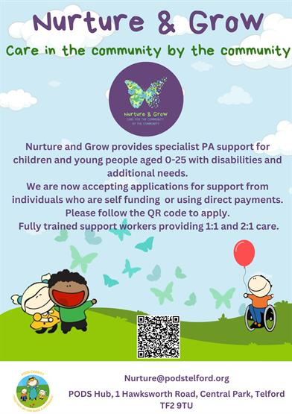
Blossom & Bloom Stay and Play Session
Blossom & Bloom is a stay and play session for infants and pre-schoolers aged 0-5. There will be fun activities every week, come for a coffee, meet other parents in our welcome and inclusive environment.
This will be open to all children prior and post diagnosis, this group every Tuesday term-time only it will run 10-11.30 at PODS hub for any extra information contact Louise@podstelford.org
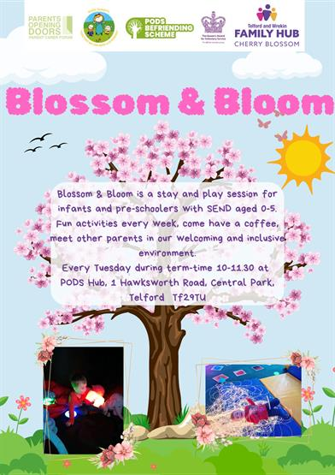
Calling all Future Artists! Developer Launches Competition to Design Art for Accessible Playground
A national housing developer has launched a competition for young people in Telford, letting them have the chance to design the art that will be showcased on its accessible play area at Hadley Gate, its development in the town.
As part of the planning permission for the development, Persimmon Homes will be creating a new accessible play area and is inviting young people in Telford to have the opportunity to have their artwork permanently displayed there. Working with PODS Parent and Carer forum, the developer has chosen nature as the theme.
Young people aged between 3 and 15 are invited to share their designs, with the team offering the winner the prize of a £100 gift card to Smyths or Amazon.
The winning design will be used as inspiration for the artist who will re-create the art, for it to be displayed permanently.
Entrants should email their design to taylor.robinson@persimmonhomes.com with the subject line ‘Hadley Arts’, leaving their name, age, school and contact information.
The deadline for entries is Friday 31st January 2025, with a winner chosen on Monday 17th February 2025.

Holiday Charity - The Adamson Trust
Shared from The Adamson Trust...
"The Adamson Trust is a long established Perthshire charity based in Crieff.
We are able to give financial help with the cost of holidays or respite breaks for disabled children aged between 3 and 17 with physical, mental or emotional impairments. We can only give help for this purpose.
Who Can Apply?
Individual families can apply and, in addition, we accept applications on behalf of groups of children, organisations and other registered charities.
How Do I Apply?
The application form asks for some detailed information about the child, and also about the planned holiday. It is essential that this is provided."
To find out more, please visit their website here: Holiday Charity - The Adamson Trust
Neurodivergent Yoga with Maggie
First Friday of the month at 4pm above Big Street, Little Feet, Madeley.
A class designed for neurodivergent individuals & their families. Tailored to support young people with special needs, providing a safe & nurturing environment to explore movement, breath, & mindfulness. All abilities are celebrated & no prior yoga experience is necessary!
Please note: The studio is in the attic space of a 3 storey building, accessible only by stairs (no lift). We have an accessible bathroom, on the ground floor. 1 booking admits 2.
To book, please click here: Neurodivergent Yoga with Maggie
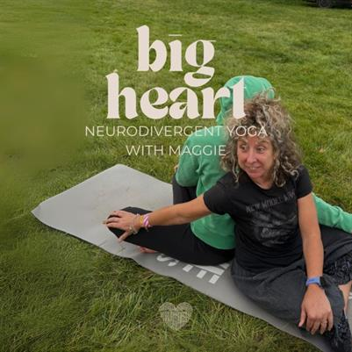
Get Connected Sessions
Please see the posters below for the upcoming Get Connected Sessions.
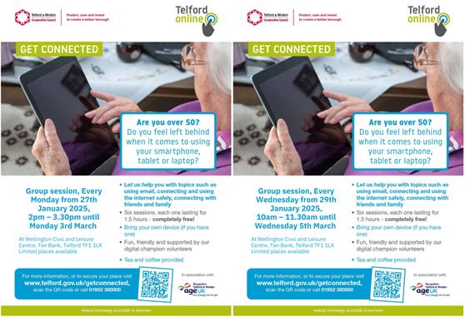
Free Digital Drop In Support Sessions
Please see the poster below for details on Telford & Wrekin's FREE Digital Drop In Support Sessions.
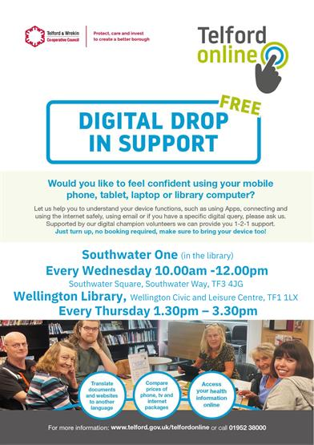
Action for Happiness Calendar - Happier January 2025
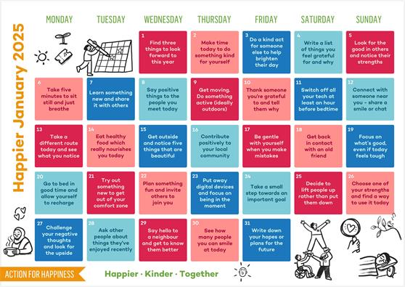
Please note the above material is subject to copyright, please contact PODS before sharing any of the information in this PODS Ebulletin.
Thank you for reading our latest Ebulletin, please stay safe & well.
Kerrie Seagrave, Member Support Co-ordinator
on behalf of PODS Parent Carer Forum.

We hope you enjoyed reading our latest e-bulletin - we hope you continue to find it useful. If you have any suggestions to make it better feel free to let me know.
If you no longer wish to receive our emails please click here


