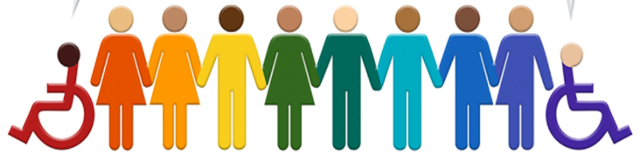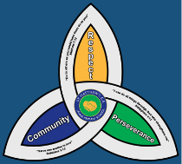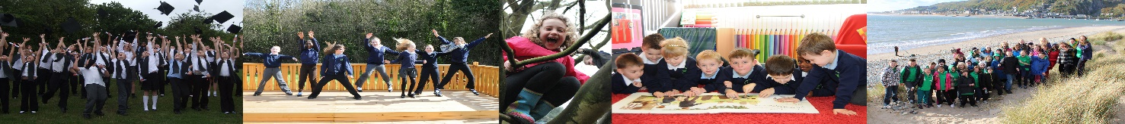I

**SEND**

**Newsletter Autumn Term 2022**

**Meet the Team**

|  |  |
| --- | --- |
|   **SENCo**  My name is **Mrs Burns** and I have recently joined the team at St Matthew’s as the SENCo. I will be overseeing the provision for all SEND pupils from Nursery through to Year 6, so I will be your first point of call if you feel that you have any concerns relating to your child’s development, learning or progress.  The SEND team at St Matthew’s are regularly looking for ways to improve the provision for SEND pupils and their parents. This SEND newsletter is a way for the team to liaise with parents sharing with you new initiatives, changes to legislation and our achievements and successes. The newsletter will be produced termly and will keep you up to date with everything that is happening in relation to SEND at St Matthew’s. |   **Deputy Head/SENCo**  My name is **Mrs Wilson** and I have been the SENCo at St Matthew’s for a considerable number of years, however over the course of this term I will be gradually handing over the responsibility of SEND to our new SENCo.  Whilst the transference of responsibility takes place I will take more of a supportive role in SEND and although I will still be available to speak to, if necessary, Mrs Burns will now be your first point of contact. Mrs Burns and I will then work together to provide the best possible support to meet the needs of your child.  I also work to support pupils and families to address issues such as attendance, punctuality, challenging behaviour, low self-esteem, lack of confidence and raising academic achievement. |
|   **Pastoral Manager**  My name is **Mrs Cadman** and I work with all children who need help to overcome difficulties that may prevent their learning. The variety of issues covered is vast, ranging from punctuality, challenging behaviour, low self-esteem, lack of confidence and raising academic achievement.  I support children to develop positive mental health and wellbeing; allowing them to enjoy learning.  I am also the school ELSA (Emotional literacy assistant support) this role enables me to support children to identify how they may be feeling and why; supporting them to manage their feelings in a positive way.  If you have any concerns regarding your child’s welfare, I am always happy to talk through them with you. | **SEND Governor**  My name is **Bev Porter**, and I am the governor with responsibilities for SEND (Special Educational Needs and Disabilities). I have a wealth of experience and knowledge in the areas of Speech, Language and Communication Needs, Autism Conditions, Dyslexia and DCD/ Dyspraxia. Having previously worked at a strategic level for the Local Authority.  In my role as governor, I aim to support Mrs Burns, the new SENCo, to provide the best possible outcomes for pupils with SEND at St Matthew’, by ensuring that matters relating to SEND continue to stay on the governing body agenda.  Parental engagement has always played a key role in a child’s education so please become involved by letting us know your comments, views, and ideas on ways forward. |

**Mental Health Practitioner**

My name is Tom Howells, I’m a Trainee Education Mental Health Practitioner here to support young people in school. I am part of the BeeU Service which is part of the NHS service. From January onwards I will be offerring1:1 and group sessions which take place in school, supporting young people with a variety of issues and concerns. I’ll be helping school to think and plan how best to support children, teachers, and parents around mental health. This will mean raising awareness of mental health, challenging stigmas surrounding mental health and working with students, teachers, and parents to find ways in which we can improve mental health provision in school. I’m very much looking forward to meeting you all.



**Contact details**

|  |  |  |  |
| --- | --- | --- | --- |
| St Matthew’s SEND Team | 01952 386260  01952 386274 | Family Connect | 01952 385385  [www.telford.gov.uk/info/20223/familyconnect](http://www.telford.gov.uk/info/20223/familyconnect) |
| Mrs L. Burns  SENCo | Laura.burns@taw.org.uk | Information Advice Support Service | 01952 457176  [www.telfordsendiass.org.uk](http://www.telfordsendiass.org.uk/) |
| PODs - Parents Opening Doors | 01952 271532  [www.podstelford.org/](https://www.podstelford.org/) | SEND Telford | [www.telfordsend.org.uk/site/index.php](https://www.telfordsend.org.uk/site/index.php) |

**Wellbeing and Mental Health – Parent Signposting**

|  |  |  |
| --- | --- | --- |
| **BEAM**  Image result for BEAM | All pupils | BEAM, run by The Children’s Society, is an emotional health and well-being service for children and young people across Telford and Wrekin and Shropshire. The service is available to anyone under the age of 25 and provides the opportunity to discuss, share and talk through problems in a non-judgemental environment.  [***https://www.childrenssociety.org.uk/beam/shropshire***](https://www.childrenssociety.org.uk/beam/shropshire) |
| **Bee U**  Image result for Bee U emotional health and wellbeing | All pupils | Bee U is another service that consists of 4 organisations (The Children’s Society, Kooth, Healios and Midlands Partnership NHS Foundation Trust) who deliver emotional health and wellbeing services across Shropshire and Telford & Wrekin. New drop-in and online services are available as well as Young People and Families Mental Health Service (previously CAMHS) to help you with; getting advice, getting help, getting more help, getting risk support  [**https://beeu.org.uk/**](https://beeu.org.uk/) |
| **KOOTH**  Image result for KOOTH | 11 years+ | A free, safe and anonymous place for young people to find online support and counselling. Kooth has a team of professionals who aim to provide early response to emotional wellbeing as well as emerging mental health needs via our online platform and counselling sessions. |
| **Young Minds**  Image result for Young Minds | All pupils | Young Minds is the UK’s leading charity fighting for children and young people's mental health. They work to support parents of children and young adults with mental health issues. The helpline provides support and advice to parents and carers worried about the emotional wellbeing or behaviour of a young person in their care with confidential, expert advice.  [**https://youngminds.org.uk/**](https://youngminds.org.uk/) |

