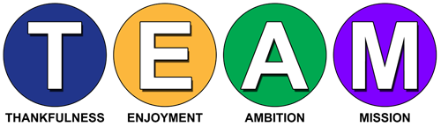
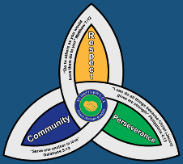
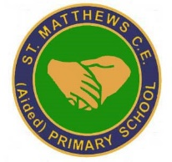

Curriculum Overview and Statement of Intent, Implementation and Impact-Phonics
Safeguarding

Safeguarding is at the centre of everything we do at St Matthew’s, we aim to ensure that everyone working in our school understands and adheres to their safeguarding responsibilities. We have a duty of care to all staff, pupils and their families. The safety and protection of all children is of paramount importance to all those involved in education. We are committed to inter-agency working to keep children safe. All of our community believe that our setting does provide a caring, positive, safe and stimulating environment, which promotes the social, physical and moral development of the individual pupil, whilst paying due regard to the protected characteristics of every child.

Equality and Diversity

As a Church of England Aided Primary School, St. Matthew’s school is rooted in Christian values and TEAM spirit, we aspire to be an innovative and inspiring community where every individual is provided with the opportunity to flourish spiritually, morally, emotionally, physically and intellectually. We are ‘Individuals working to potential with God’.
The school is committed to:
- promoting racial equality, good race relations and challenging racial discrimination. This is reflected in all school policies, procedures, processes and practices.
- ensuring that it is a place where everyone, irrespective of their race, colour, ethnic or national origin or their citizenship, feels welcome and valued and able to achieve their full potential.
- protecting the rights of all pupils, staff, parents, governors and visitors to the school.
- respecting and valuing differences between people.
- meeting the diverse needs of pupils.
- preparing pupils for life in a multi-ethnic society.
- acknowledging the existence of racism and being proactive in tackling and eliminating racial discrimination.

Intent  At St Matthew’s Primary school, our school vision is to encourage all children to flourish spiritually, morally, emotionally, physically and intellectually in all aspects of life demonstrating perseverance and resilience; this is emulated across all curriculum areas.  Read, Write, Inc (RWI) is a consistent, rigorous and creative phonics programme designed to teach every child how to read. Using synthetic phonics, children quickly learn to blend letter sounds together following a fun, effective and inclusive programme to enable children to flourish as readers. Furthermore, RWI is used as an additional intervention programme to secure reading skills for children not making expected progress with phonics. We want the children to experience wonder and enjoyment through reading igniting imagination and a love of books As a school, we are determined that every pupil will learn to read, regardless of their background, needs or abilities. The school has clear expectations of pupils’ phonics progress and we ensure that the teaching of reading is of an excellent standard to create children who take pleasure in reading. | Implementation  Through the teaching of the RWI phonics programme the children are taught the essential skills needed for reading. Phonics is taught daily to all children in Foundation Stage, and KS1. Extra support is provided to those in Year 2 who have not passed phonics screening in Year 1 and interventions are planned for those children who are working below expected levels. Staff systematically teach learners the relationship between sounds and the written spelling patterns, or graphemes, which represent them. Phonics is delivered in ability groups across EYFS and KS1 to enable children to make rapid progress in their literacy skills. Pupils have regular reading sessions with an adult we ensure the pupils are regularly practising and applying their phonics knowledge. In the EYFS the continuous provision matches the pupil’s current knowledge and understanding whilst ensuring the children are suitable challenged. Reading leaders regularly assess the pupil’s phonics knowledge using RWI assessments. These regular assessments inform planning and allow teachers to identify any gaps in learning. The children have reading books which they are encouraged to read regularly at home which match their current phonics level. | Impact  At St Matthew’s, through our consistent teaching of systematic phonics, our aim is for children to become fluent readers by the end of Key Stage One. This way, children can focus on developing their fluency and comprehension as they move through the school. Attainment in reading is measured using the statutory assessments at the end of Key Stage One and Two. These results are measured against the reading attainment of children nationally. Attainment in phonics is measured by the Phonics Screening Test at the end of Year 1. However, we firmly believe that reading is the key to all learning and so the impact of our reading curriculum goes beyond the results of the statutory assessments.

