Science  As Scientists, we will be exploring the unit called  ‘Switched on.’  Here we will be introduced to the topic of electricity, the dangers of Electricity, how to create simple circuits, where we will make a bulb light up, a buzzer make a sound and explore how switches can work in a circuit.  We will also explore which materials are Conductors of electricity and which are insulators.  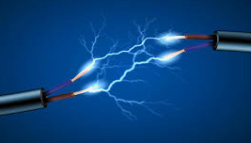 | RE  Come follow Christ in the footsteps of St Chad. What is prayer all about?  - For spiritual and moral development, we will… Pupils know that Christians talk to God when they pray. Pupils know that people of all faiths pray. Pupils can write prayers. |  |  |  | Maths  As mathematicians, we will:  Yr 3: Number: Multiplication and Division (3 weeks)  Measurement: Length and Perimeter (3 weeks)  Yr 4: Number: Fractions (3 weeks)  Number: Decimals (3 weeks)  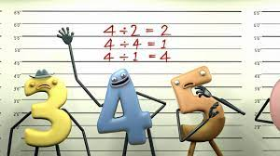
 | English
 | Fiction | Grammar and punctuation |  | Reading
 | Letters  - First person  - Formal language  - Informal language  - Imperative verbs  - Rhetorical questions  - Exaggerated language  - First, second, third person  - Emotive language  - Opinion  - Formal language | We will be learning….  to indicate grammatical and other features by: using commas after fronted adverbials. indicating possession by using the possessive apostrophe with plural nouns. using and punctuating direct speech. |  | Greek Mythology  Usbourne books  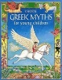  A collection of the best-known Greek myths with further insights into the world of history and tales of brave heroes, powerful gods, and terrible monsters.
St. Matthew’s CE (Aided) Primary School and Nursery Centre
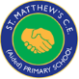 Half-termly Curriculum Map for Class 1
Spring 2 2024 – Class 3/4 St Sophia
Fancy Fabrics
D&T  As design technologists, we will:  Fancy fabrics  This project teaches children about home fabric products and they use their learning to create printed and embellished fabrics.  Focus – Materials  (Design and create a Greek inspired embellished fabric’) | Music  As musicians we will…  Learn how to play the ukelele and perform to an audience for our Christmas concert production.  Learn how to play individual notes and chords.   |  | Computing  Let’s Give Credit  Data and information  Introduction to Databases |  | Spanish  As linguists and learners of Spanish, we will explore the unit Face and body parts.  (Face and body parts nouns and commands, yoga with body parts, alien creation)
Co-Jo  Yr 3: Sir Ernest Shakleton  Shackleton was able to successfully explore the Antarctic several times, though not without enduring several dangerous challenges that he encountered while on his expeditions.  Yr 4: Kira Salak  Kira Salak is a writer, adventurer and journalist. | PSHE  As members of our community, we will explore the unit ‘Dreams and Goals.’ Here will discuss and explore our aspirations for our own futures. |  |  |  | PE  Inside – Karate  Outside - Tennis

