Science  As Scientists, we will…  - Be exploring the topic ‘Who am I?  - I can identify and name a variety of different living things in their local and wider environment  - I know plants and animals can be grouped using a wider range of characteristics  - I know classification keys are used for the identification of animals and plants  - I know that living things can be grouped in a variety of ways | RE  For spiritual and moral development, we will…  Asking the question ‘What kind of world did God want?’  Pupils will know that Christians believe that through his teachings Jesus challenges everyone about the way they live.  • Pupils will know that Jesus first disciples left their jobs and families to follow Jesus.  • Pupils will know that it is claimed that Jesus could heal a leper. By doing this Christians believe that showed love for those that others ignore. They can relate this to the activities of the local church and of Christian charities.  • Pupils will know what a parable is. Pupils can retell the parable of the Good Samaritan (including the man being attacked, the Levite and the priest passing by, the Samaritan stopping to help, and that Jesus asked who was this man’s neighbour).  • They can describe the work of a Christian charity that tries to put this teaching into practice e.g. Christian Aid. They should know that people of other faiths and of none also run charity work. |  |  |  | Maths  As mathematicians, we will:  - Be learning strategies to multiply and divide numbers.  - Revising addition and subtraction strategies also.  - Learning how to measure lengths accurately, using cm, mm and m.  - Measuring the perimeter of regular and irregular 2d shapes.  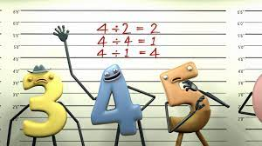
 | English
 | Fiction | Grammar and punctuation |  | Reading
 | Narrative-fantasy  - First or third person  - Inverted commas  - Similes  - Metaphors  - Onomatopoeia  - Noun phrases  - Varied sentence openers  - Synonyms  - Antonyms  - Informal or formal language Emotive language | We will be learning….  How to use a greater variety of subordinating conjunctions in order to create more complex sentences.  Focussing on spelling many of the words from the year ¾ spelling list correctly.  Identifying and using homophones, they’re, there and their.  Writing detailed expanded noun phrases. |  | Greek Mythology  Usbourne books  A collection of the best-known Greek myths with further insights into the world of history and tales of brave heroes, powerful gods, and terrible monsters.
St. Matthew’s CE (Aided) Primary School and Nursery Centre
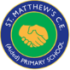 Half-termly Curriculum Map for Class 1
Spring 1 2023 – Class 4 (Y5/6)
Gods and Mortals
History  As historians, we will:  Develop knowledge of the ancient Greeks. Children learn how and when the ancient Greek civilisation flourished, and understand their culture, armies and heroes. | Music  As musicians we will…  Learn how to play the ukelele and perform to an audience for our Christmas concert production.  Learn how to play individual notes and chords.  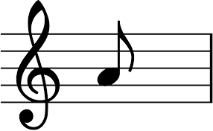 |  | Computing  Online Safety  ‘Do I know you?’  A programme of study where we look at ways to stay safe online.  To ensure we recognise the importance of keeping our personal details safe in order o remain safe when we are online. |  | Spanish  As linguists and learners of Spanish, we will…  Family tree and faces  (Epiphany, family members, personal info, face parts, describing with colours)
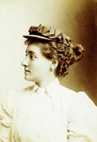  Yr 3 Explorer - Annie Kopchovsky  Annie Cohen Kopchovsky’s (aka Annie Londonderry) bike ride between 1894 and 1895 was, the New York World declared, “the most extraordinary journey ever undertaken by a woman.” The married mother of three children under the age of six was attempting to become the first woman to ride around the world by bicycle. The name “Londonderry” came from the first of several corporate sponsors of her journey, The Londonderry Lithia Spring Water Company of Nashua, New Hampshire. Though she is often heralded as the first woman to circle the world on a bicycle, but there is much more to Annie’s story than meets the eye.  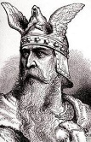  Yr 4 Explorer – Leif Erikson  Leif Erikson is a Norse explorer who was amongst the first Europeans to reach North America, centuries ahead of Christopher Columbus. The sagas of his voyage have caused a historical debate. Some claim that Erikson’s landing in America was accidental; others claim he sailed there on purpose after hearing about the lands from earlier explorers. Explorers this term will learn about Norse mythology and the treacherous life of the Vikings. | PSHE  As members of our community, we will…  ‘Changing me.’  - Being me in my world  - Celebrating differences  - Dreams and goals  - Healthy me  - Healthy relationships  - Physical and emotional changes that happen to me |  |  |  | PE  As dancers, gymnasts, athletes, players and orienteers we will…  Be learning the art of karate  During our outside PE sessions we will be learning how to play the team game ‘Tag rugby.’  Focussing on being a team player, supporting each other and learning new skills and rules according to the game.

