Science  As Scientists, we will…  Be exploring the topic, Light and Dark | RE  For spiritual and moral development, we will…  Learn about Salvation: Why do Christians call the day Jesus died ‘Good Friday’? |  |  |  | Maths  As mathematicians, we will:  - Revisit place value  - Recognise adding and subtracting fractions  - Use unit and non-unit fractions to find fractions of an amount.  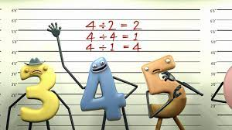  - Identify decimals and fractions as tenths and hundredths
 | English
 | Fiction | Grammar and punctuation |  | Reading
 | Recounts: Newspaper Reports  During our writing lessons, we will be exploring the us of the following to create our own newspaper reports:  - Adverbials of time  - Direct and reported speech  - Inverted Commas  - The 5 Ws | We will be learning….  How to use full stops, capital letters, commas, questions marks, inverted commas for speech and exclamation marks in our sentences.  To use the correct determiners.  To use the correct perfect present, past or future tense.  Learn to edit and redraft my own writing independently to check for grammatical errors. |  | The Iron Man  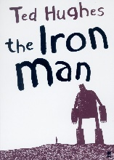  Ted Hughes
St. Matthew’s CE (Aided) Primary School and Nursery Centre
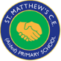 Half-termly Curriculum Map
Summer 1 2025 – St Sophia (Y3/4)
  Art  Festival Feasts  Focus Artists: Claes Oldenburg and Lucia Hierro | Music  As musicians we will…  Exploring the unit – This Little Light of Mine.  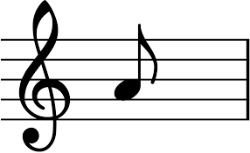 |  | Computing  As computing scientists we will:  Learning how to use PowerPoint presentation. |  | Spanish  As linguists and learners of Spanish, we will…  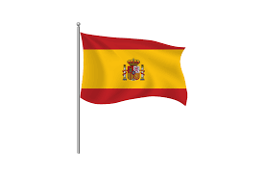  My Routine
History  I am Warrior  - The chronology of the Roman Empire  - What life was like as a Roman child  - Different types of gladiators | PSHE  As members of our community, we will…  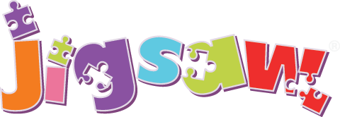  Jigsaw unit- Relationships |  |  |  | PE  As athletes, we will:  Athletics

