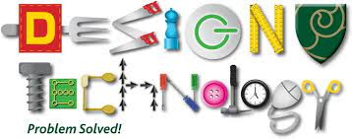Design and Technology Topic Overview 2024

Cycle A: 2024-2025 Cycle B: 2025-2026

KS1: Year 1 and 2

|  |  |  |  |
| --- | --- | --- | --- |
| Cycle | Autumn 2 | Spring 2 | Summer 2 |
| A | Chop, Slice and Mask  (Food) | Cut, Stitch and Join  (Textiles) | Push and Pull  (Mechanisms) |
| B | Remarkable Recipes  (Food) | Taxi  (Mechanisms) | Beach Hut  (Structures) |

LKS2: Year 3 and 4

|  |  |  |  |
| --- | --- | --- | --- |
| Cycle | Autumn 2 | Spring 2 | Summer 2 |
| A | Fresh Food, Good Food  (Food) | Green House  (Structures) | Making it Move  (Mechanisms) |
| B | Scrumdidlyumtious  (Food) | Torches/Buzz game  Electrical Circuits and Conductors  **Project on a page** | Functional and Fancy Fabrics  (Textiles) |

UKS2: Year 5 and 6

|  |  |  |  |
| --- | --- | --- | --- |
| Cycle | Autumn 2 | Spring 2 | Summer 2 |
| A | Eat the Season  (Food) | Make Do and Mend  (Textiles) | Burglar Alarms  (Electrical Circuits and Components) |
| B | Food for Life  (Food) | Exploring Pneumatics  (Mechanisms) | Engineer  (Structures) |