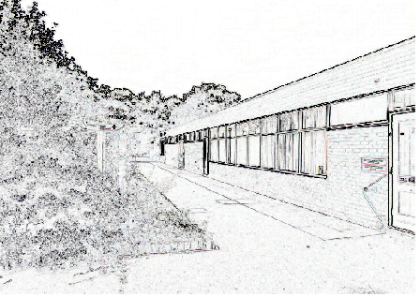

‘Individuals, Working to

Potential, Together’



St. Matthew’s Church





3rd September 2019

Dear Parents/Guardians

**30 Hours Free Childcare for 3 and 4 year olds**

You may be aware that from September 2017 the Government is introducing 30 hours free childcare.

Here at St Matthew’s we have made the decision to offer 10 places in our nursery to families eligible for the 30 hour provision. The places will be offered on a first come first served basis.

A copy of our new Nursery Admissions Policy is attached which explains the admissions procedure in details. A copy of the qualifying criteria from the Department for Education is also attached.

However, in brief, if you are interested in the 30 hours then you should :-

1. Make contact with Mrs Overal in the school office to register your interest.
2. Register your details at <https://childcare-support.tax.service.gov.uk/par/app/applynow>. This website provides all information regarding the funding.
3. If eligible you will be given a code which should be brought into Mrs Overal along with your National Insurance number and the child’s date of birth.
4. You will be asked to complete a Privacy Notice to enable us to process your information with the Inland Revenue.
5. Once approved you will then be contacted by Mrs Overal to advise of the next step.

Parents are required to apply one term before they are eligible which is why you should be applying now ready for September.

It is the parent’s responsibility to ensure that they check every 3 months to ensure they are still eligible.

If no longer eligible then you will be offered a 15 hours place (if one is available).

From September our nursery hours will change slightly. For 15 Hour a week morning session will be from 8.40 am until 11.40 am. Afternoon sessions will be from 12.15 pm - 3.15 pm.

30 hour sessions will be from 8.40am to 3.15pm. Lunch for those children attending all day will be from 11.40am to 12.15pm. There is a cost for this period of time as it over and above the 30 hour provision. The cost will be a nominal fee of £10 per week. Parents should supply their child with a packed lunch and water bottle.

If you have any queries at all then please do not hesitate to contact me.

Kind regards

Mrs Clark

***School Business Manager/Head’s PA*** Mrs J. Overal jayne.overal1@taw.org.uk

***School Administrative Officer*** Miss Jessica Fenn

Jessica.Fenn@taw.org.uk

yvette.miles@taw.org.uk

***Website:*** www.stmatthewscofe.co.uk ***Follow us on Twitter:*** @stmattsprimary

***Chair of Governors*** Mrs A. Hill

annahill4784@gmail.com

**Nursery Leader** Miss S. Vaughan BA (Hons)

sophie.vaughan@taw.org.uk

*Assistant Head & SENCO* Mrs R. Wilson B Ed (Hons)

rebecca.wilson2@taw.org.uk

*Deputy Headteacher* Miss T. Cartwright B Ed (Hons)

tracey.cartwright@taw.org.uk

*Headteacher* Mrs K. Clark B Ed (Hons)

Kate.clark@taw.org.uk

*St Matthew’s CE (Aided) Primary School And Nursery Centre*

*Church Road, Donnington Wood, Telford TF2 7PZ*

*Telephone : 01952 386260*

*Mobile : 07471 730103*